Foundations of Computer Science:

CGP Project Report
2014/15

Is Responsive Web Design the Solution to a Growing Problem in Content Delivery
Kieran Warren
100332570

Abstract:
The growing variation of device sizes has caused issues for the content being produced for them. Websites originally being designed for desktop monitors do not scale well to a small mobile phone and so there have been attempts at finding a solution to this problem. The original solution was mobile applications but these too became limited and more difficult to develop with varying phone sizes and tablets. Application development alongside a desktop website would also be much more costly to produce.
In recent years Responsive Web Design has become a more popular solution allowing websites to scale correctly and easily across any kind of device.
Table of Contents
Abstract: 1
Introduction: 3
The Web, Applications and Their Need to Evolve 3
The Solutions to Responsive Design, How They Work and Issues Involved. 5
Conclusions 7
Bibliography 7

Introduction
Compared to just a few years ago, the variation of devices accessing content on the web has increased a huge amount since the creation of smart phones and tablets. Since then there has been a struggle to find a way to deliver content to all of these devices in the simplest manner with the least cost to a developer. At the beginning of the smartphone era the solution to getting websites onto phones and tablets has been to develop an application to run natively on the smartphone operating systems such as Android and iOS. An expensive procedure due to a separate project and possibly different development team being required.
Increasing variation in devices is not the only reason for more responsive designs. Multitasking and higher resolution desktop screens has meant that desktop applications need to be able to use the entire screen as well as only a small section when being used alongside other applications. Some desktop applications have had some responsive design added to them although most scale horrible on both high resolutions and low resolution windows.
In recent years the biggest solution to this problem has been to implement responsive web design into websites. This enabled a pleasant viewing experience on all devices from the largest desktops down to the smallest mobile phones. Responsive web design has only become a feasible idea since the release of HTML5 which has enabled higher flexibility in website design and websites have become less static. In other words, websites have become more responsive to the environment they are in and the device they are being used on, hence it being commonly referred to as responsive web design.

The Reasons Responsive Design is Needed

Varying device size
Since smart phones were released there has been a growth in the access rate from small devices and portable devices are now a more popular method of accessing websites than the traditional desktop as stated by comScore on TechCrunch (2014). This rise in access from smaller devices meant that content needed to be displayed to them in a way appropriate to the screen size. The first step towards this was mobile applications and both the Apple application Store and Google Play Store have more than 1 million applications available – Statista (2014).

However, like the desktop website issue that applications were designed to solve, they have caused a similar problem with the growth of tablets and small laptops. The applications are not always suited to these devices with slightly larger screens and the traditional desktop websites are not suited to these devices either. A solution for this issue may just be to create another application for tablets but this would only temporarily solve the issues with mobile applications at the moment. What will happen when more people want to view this content on a smart watch, or maybe something even smaller than that. Instead of creating a number of static applications or website versions that only work with one device size, the solution would be for a responsive design that can adapt to its environment and the resolution it is being displayed at. That is why responsive web design is needed for more websites and is a better solution to mobile applications which is currently the main method of getting desktop websites onto mobile devices.
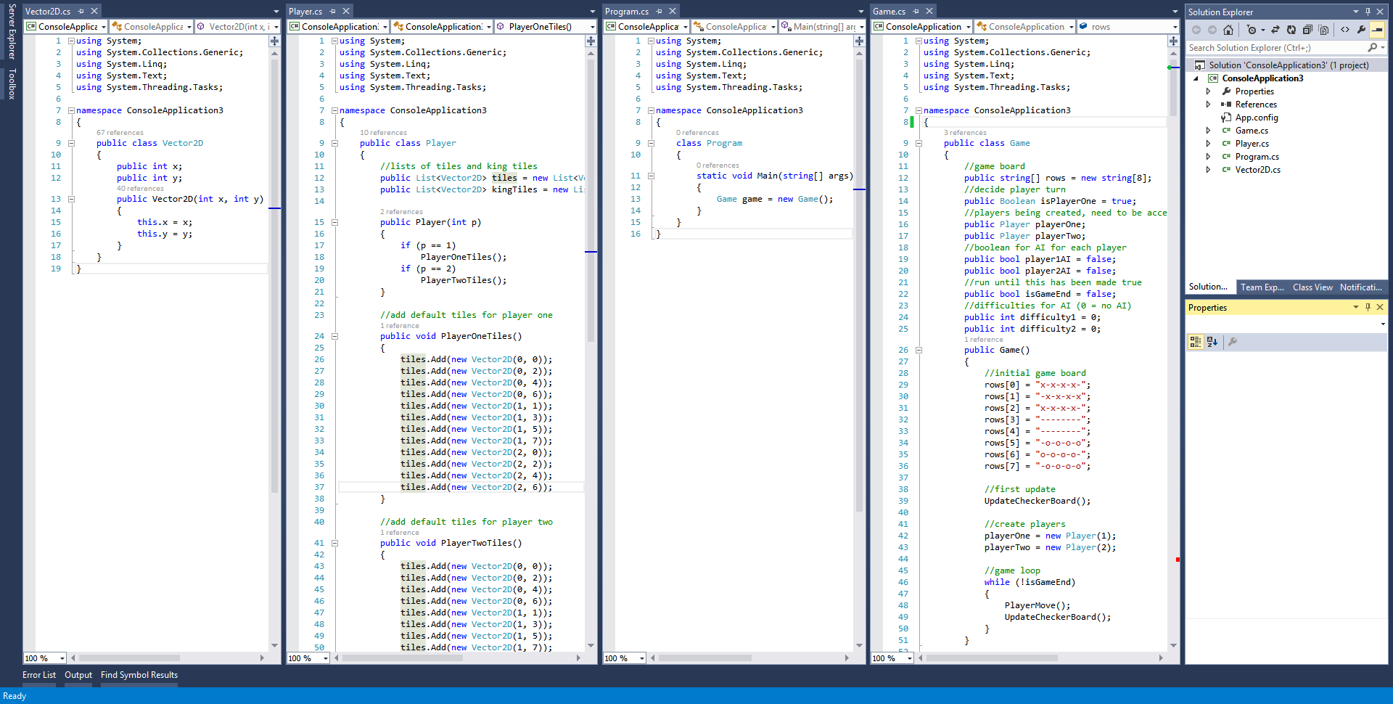
Figure 1: Visual Studio allowing view of multiple documents in different windows

Multi-Window Configurations
Smaller window sizes are not only taken advantage of by mobiles. Desktop and laptop users also like to take advantage of having multiple windows and most modern operating systems offer features to allow for easy multiple window configurations. However the current implementations are very basic. In Figure 2a you can see an application for Windows 8 running in full screen mode. It has a lot of wasted space. The smaller version (Figure 2b) does however respond to its smaller resolution and the interface is changed to work better with that. This kind of responsive design could be very useful for multiple window configurations of all kinds but must respond better to more resolutions so that when a screen is divided into multiple windows, none of the space is wasted.
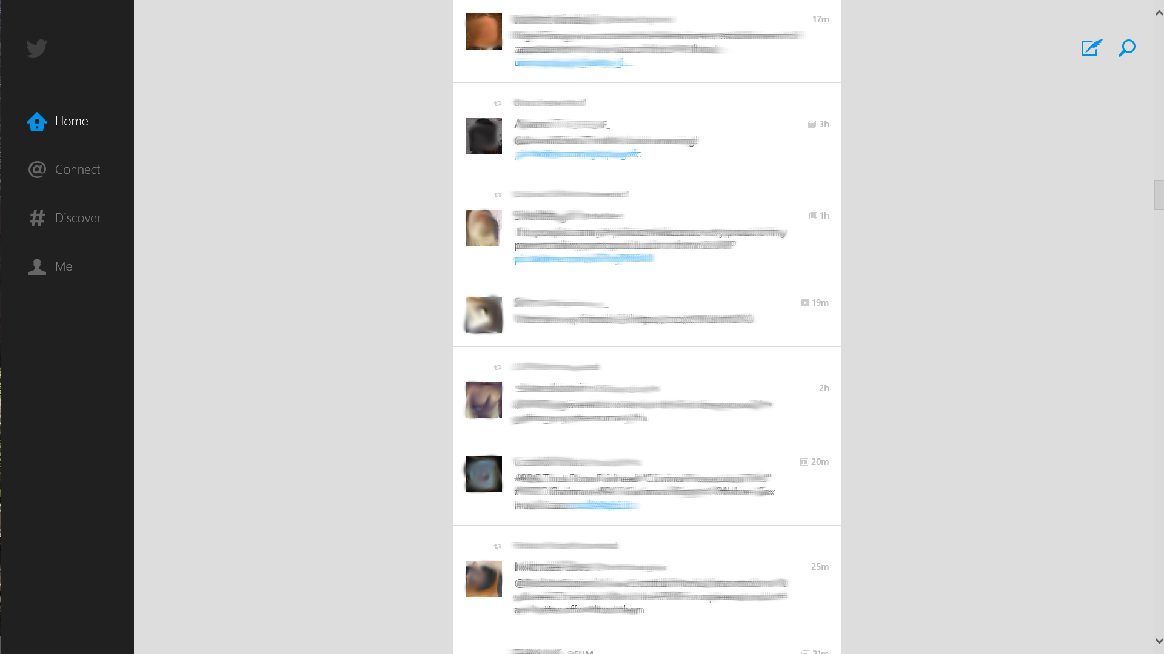

Figure 2: a) Wasted space on large screen. b) Improved design on small screens.

The Solutions to Responsive Design, How They Work and Issues Involved.

HTML5/CSS Responsive Web Design

The solution to responsive design on the web has only been easily accessible since the release of HTML5. The additions to the HTML5 mark-up language include media handling within the code – Web Design (2013). The benefits of HTML being the main platform for responsive web design is that it is already the standard for web development across most websites and is compatible with almost all devices. Web Design (2013) also mentions that HTML5 is easier to develop for and also much faster. Speed being a very important factor for mobile phones.

If HTML5 is easier to use for development, especially with producing responsive web sites, it would make the change from static websites designed primarily for desktops to a site that can be displayed on any device much quicker than without similar development tools.

XAML Responsive Application Design (Windows)

With Windows 10 in development, one of the features being shown off is the responsive design of applications designed for its operating system. For responsive design, Windows uses XAML. The use of XAML allows the application to run on all Windows devices from their mobile devices up to the TV screen on the Xbox One.

Unlike responsive design on the web, XAML does not use media queries or flexible image size through CSS but instead uses the Visual State Manager (VSM) – Jay On Windows (2015). Figure 3 is an example of the code used for responsive design in XAML. Figure 4 is an example of this responsive design in action with the Outlook application for Windows 10 displayed in different resolutions and aspect ratios.

private void ResponsivePage_SizeChanged(object sender, Windows.UI.Xaml.SizeChangedEventArgs e)
{
if (e.NewSize.Width > 1170)
{
VisualStateManager.GoToState(this, "Large", true);
}
else if (e.NewSize.Width > 970)
{
VisualStateManager.GoToState(this, "Medium", true);
}
else if (e.NewSize.Width > 650)
{
VisualStateManager.GoToState(this, "Small", true);
}
else
{
VisualStateManager.GoToState(this, "ExtraSmall", true);
}
}
Figure 3: Code in Visual State Manager for responding to screen size.

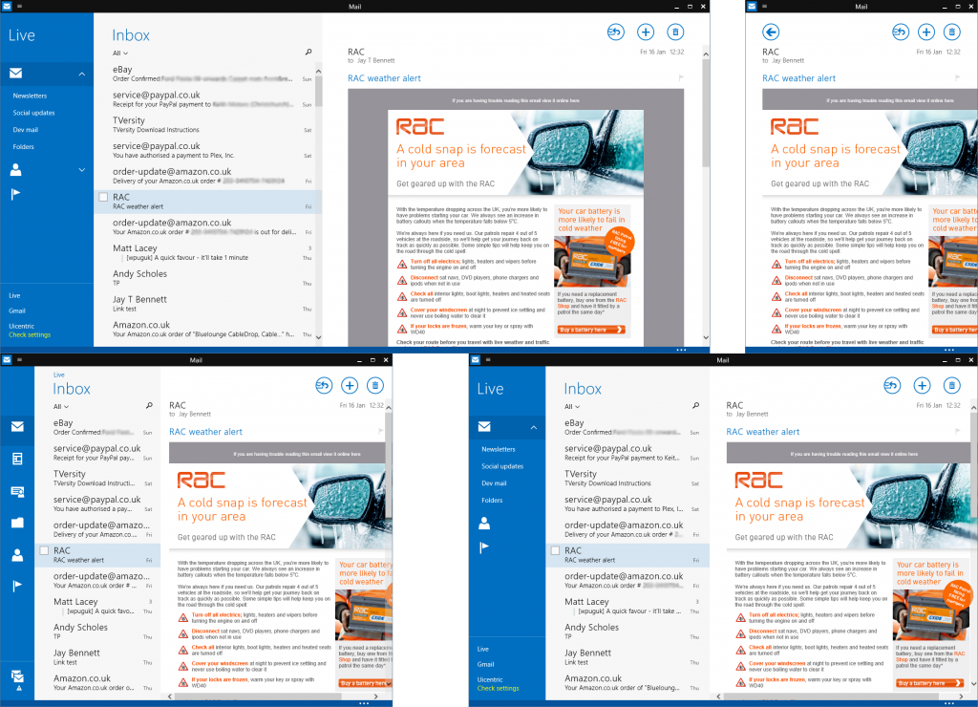
Figure 4: Outlook for Windows 10 responsive design. Source: Jay On Windows (2015)

The Issue of Pixel Density

As mentioned above, the biggest problem is the resolution of devices and not just their size. Many high-end phones use screens with a higher resolution than a HD TV, such as the Samsung Galaxy Note 4 (GSM Arena, 2014). This can cause issues with the application/web page adapting to the resolution of it and not for the screen size resulting in the application/web page being extremely difficult to use and access. CSS solves this issue by using virtual pixels (HowDesign, 2014) which can be calculated by the kind of device being used. For a mobile phone, regardless of its resolution, this virtual pixel value would be set low so that the content can load in the appropriate format. The content will still be able to take full advantage of the content and won't be pixelated due to it using a scaled down resolution.

private void ResponsivePage_SizeChanged(object sender, Windows.UI.Xaml.SizeChangedEventArgs e)
{
if (e.NewSize.Width > 1170)
{
VisualStateManager.GoToState(this, "Large", true);
}
else if (e.NewSize.Width > 970)
{
VisualStateManager.GoToState(this, "Medium", true);
}
else if (e.NewSize.Width > 650)
{
VisualStateManager.GoToState(this, "Small", true);
}
else
{
VisualStateManager.GoToState(this, "ExtraSmall", true);
}
}
Figure 4: Code in Visual State Manager for responding to screen size.

Graceful Degradation

The term graceful degradation is used to describe the method of web development where priority is given to modern devices using modern browsers, giving them the best experience possible. This will use all of the latest technologies available to developers. The experience will then degrade gracefully for users on older browsers -SitePoint (2009). There is still a large number of users that are still using old browsers that are not compatible with new technology and take up no more than 20% of the overall browser share, Net Market Share (2015) and they may experience compatibility issues with websites using newer technologies than their browser can handle.

What graceful degradation for various device types means is that the website would be primarily designed for PCs and laptops. For tablets and mobiles, they would get an inferior version of the website that may not be the best possible for their device. Features of the website may be removed to keep the mobile websites fast, compatible and easy to use on those smaller devices – Zurb.com.

Progressive Enhancement

Contrary to graceful degradation, progressive enhancement starts from the poorest devices and works upwards adding features to the browsers that can handle them – SitePoint (2009). Unlike graceful degradation, it will not always use the latest technologies at all times, but it will remove any compatibility issues on those devices that can not handle the latest technologies. If a video player was not compatible with a browser or device, it would be hidden from site unlike graceful degradation and the video would only become visible on browsers that fully support it.

Mobile device experience would for the most part be better on a website developed through this method than a website developed through graceful degradation because the site is specifically designed to work across as many browsers as possible. Desktops would not necessarily get the best experience possible and the technology that their browser can use may not be implemented at all but it should still be fully functional and there is a lower chance of compatibility issues due to it using older standards that are used in almost all browsers.

Comparison of Methods

To decide which method of web development would be best would depend on the kind of users accessing the website. A website that is accessed far more by mobiles and tablets would most likely provide a better user experience for most people accessing the site. For a website used mostly by desktop users, graceful degradation would likely be the better choice for the majority of their users.

Both methods have their differences but are pretty much the same just the opposite way around. Progressive enhancement would likely be slightly better on a mobile and graceful degradation would likely be slightly better on a desktop but if the developer is good enough they can make a good website for all devices using either method.

Conclusions
In a world of growing device variation, it would be ridiculous to think that in the coming years responsive design won't become more popular and won't be more necessary than ever before. Smartphones and desktops won't be the only devices that developers will need to design their web pages or apps for. Smart watches have recently become more popular and these users will want websites optimized for their tiny and sometimes round screens. Smart TVs are also becoming more popular meaning that websites may soon need to be better optimised for very large screens so that websites can be used in the living room.
For web development the current best method for responsive web design is certainly through HTML5. There is no doubt about that and there is hardly any real competition to it on the web. However not everything is done on the web and applications on both PCs and mobile phones need to have a responsive design and the only proper attempt we have seen at this is XAML by Microsoft. XAML is highly compatible for all of their devices and not only includes responsive design on a single screen, but apps written with XAML work instantly with all of Microsoft's devices including Windows Phones, Windows Tablets, Windows PC's and the Xbox One. Each one also adapting to the design language used for that device. XAML is currently not a fully developed tool but has been in development alongside Windows 10 where it will be best taken advantage of. Once Windows 10 has been released we should see just how good XAML is and whether it will be a viable solution in the long term.
The only issue with XAML is that it is only compatible with their devices and not all of devices run on Microsoft software. So we need to see efforts for responsive design in applications on other operating systems like Mac OS X, iOS and Android. Currently the responsive design that these devices can use is very basic and only allows for basic responsive design like stretching a bar across the width of the screen. If they want their operating systems and apps to be able to run across all kinds of devices.
Out of the two main development methods of responsive design neither really shines above the other. Both are quite similar. The choice is simply down to which devices you wish to better optimize for, but all devices could be well catered for with both methods of development. For that reason I can't recommend a single method of development to everyone but instead would say to look at what kind of devices you want to prioritise and choose like that.

Bibliography

Beale, S. (2014). Hardware + CSS Pixels in the Age of Retina Display. Available: http://www.howdesign.com/featured/hardware-css-pixels-retina-display/. Last accessed 24th Apr 2015.

Bennett, J. (2015). Getting Ready for Windows 10 with Responsive Design. Available: http://www.jayonwindows.com/getting-ready-for-windows-10-with-responsive-design/. Last accessed 24th Apr 2015.

Buckler, C. (2009). Progressive Enhancement and Graceful Degradation: an Overview. Available: http://www.sitepoint.com/progressive-enhancement-graceful-degradation-basics/. Last accessed 24th Apr 2015.

Gabriel, M. (2013). The Relationship Between HTML5 and Responsive Web Design. Available: http://www.webdesign.org/the-relationship-between-html5-and-responsive-web-design.22342.html. Last accessed 24th Apr 2015.

Perez, S. (2014). Majority Of Digital Media Consumption Now Takes Place In Mobile Apps. Available: http://techcrunch.com/2014/08/21/majority-of-digital-media-consumption-now-takes-place-in-mobile-apps/. Last accessed 24th Apr 2015.

Unknown Author. (2014). Number of apps available in leading app stores as of July 2014. Available: http://www.statista.com/statistics/276623/number-of-apps-available-in-leading-app-stores/. Last accessed 24th Apr 2015.

Unknown Author. (2015). Samsung Galaxy Note 4. Available: http://www.gsmarena.com/samsung_galaxy_note_4-6434.php. Last accessed 24th Apr 2015.

Unknown Author. (2015). Desktop Browser Version Market Share. Available: https://www.netmarketshare.com/browser-market-share.aspx?qprid=2&qpcustomd=0. Last accessed 24th Apr 2015.

Unknown Author. (n.d.). Graceful Degradation. Available: http://zurb.com/word/graceful-degradation. Last accessed 24th Apr 2015

